- Configure VPC peering in cross regions.
Step 1: Create 2 instances in 2 different regions.
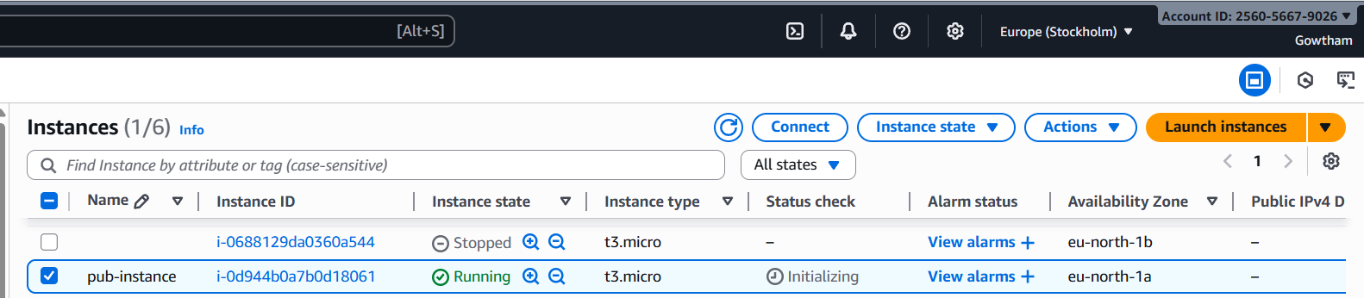
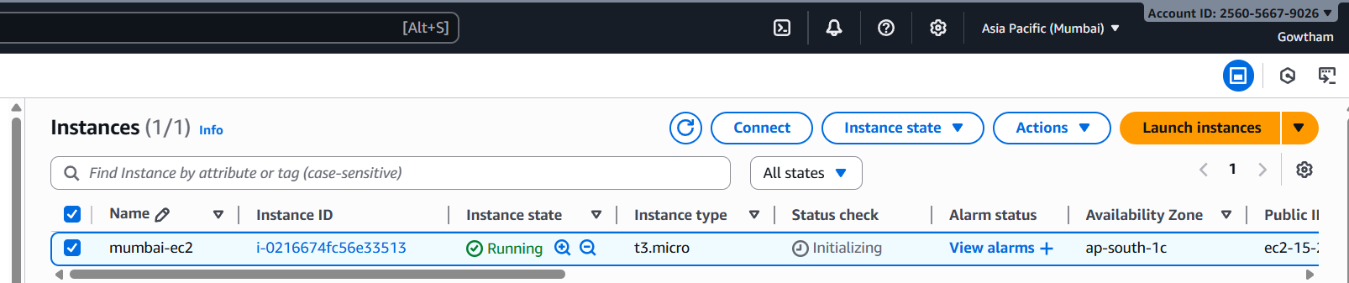
Step 2: Goto VPCPeering connectionscreate peering connectionEnter detailscreate peering connection.
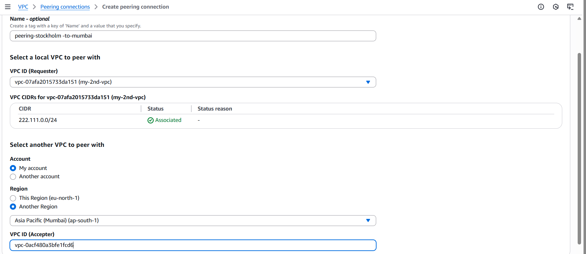

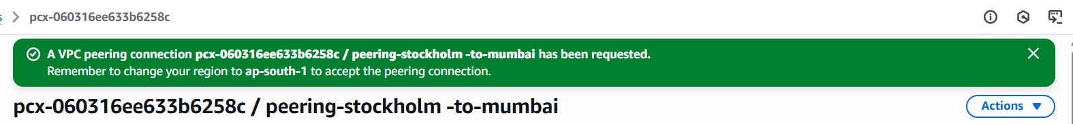

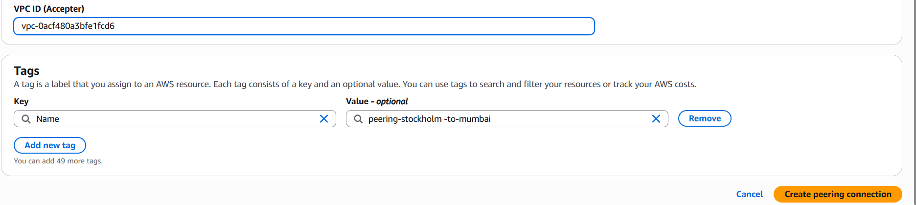

Step 3: Accept peering request in other region and modify route table in both VPC.
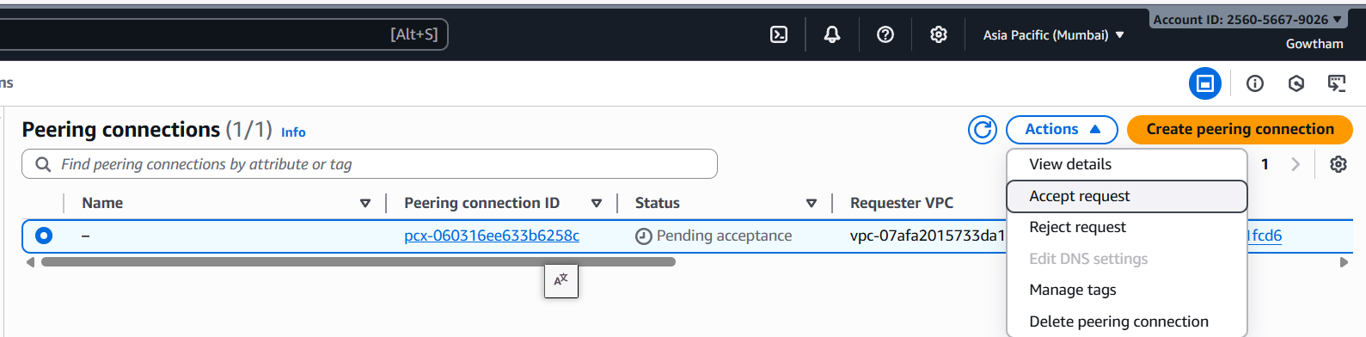
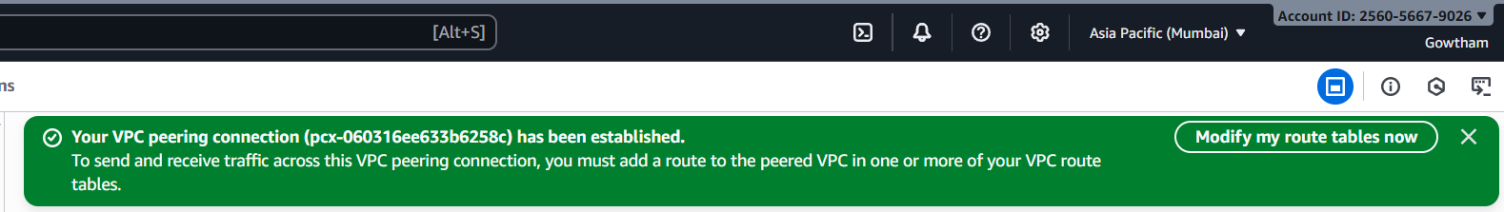
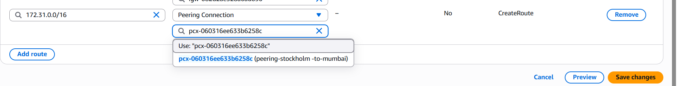
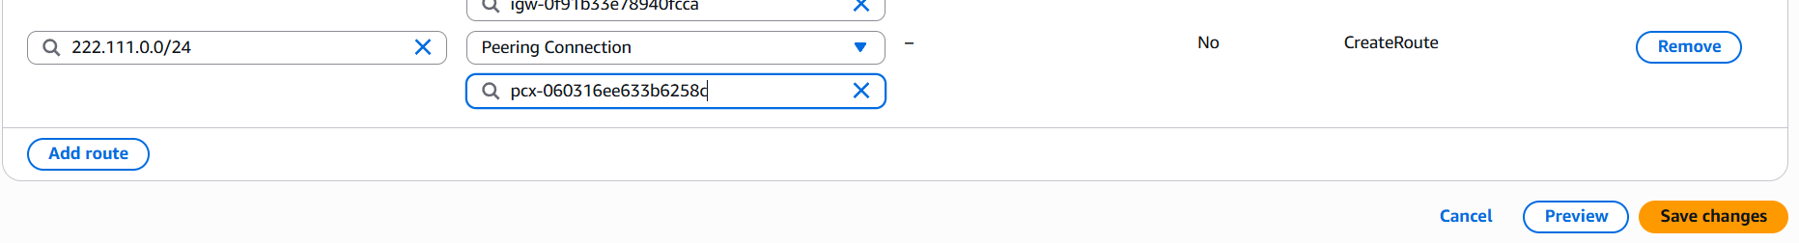
Step 4: Ping private ip of an ec2 of one vpc from another ec2 of another vpc.
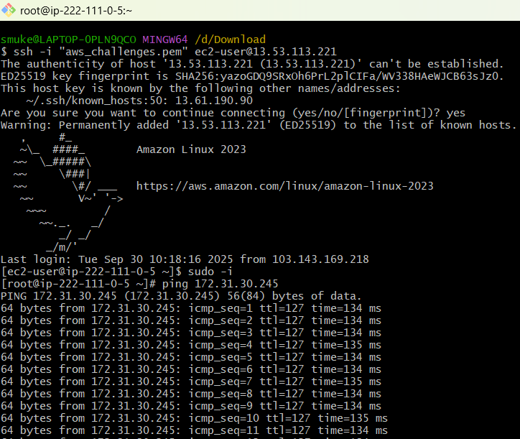

- Purchase one domain from GoDaddy.
Step 1: Goto godaddy.com and search for the domain you want and select make it yours.
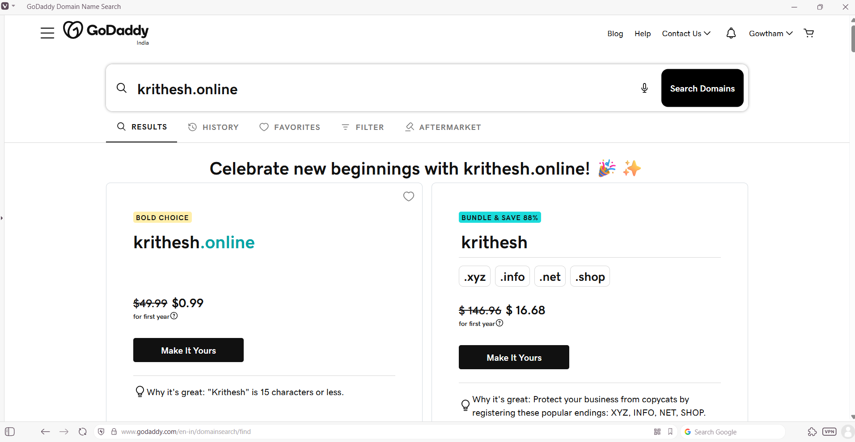
Step 2: In cart page select Ready for checkout.
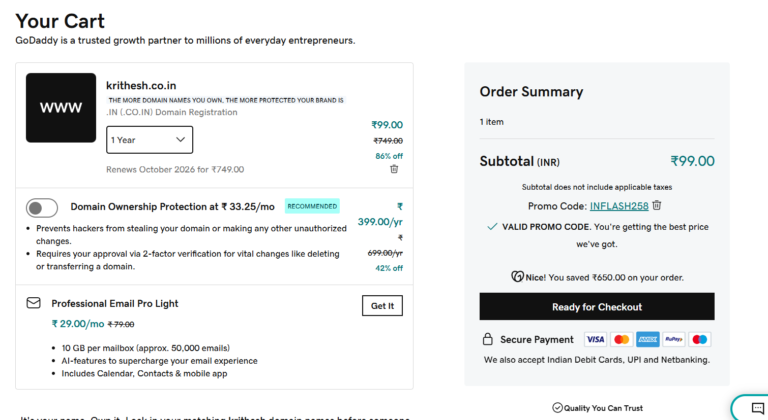

Step 3: Provide payment details and pay.
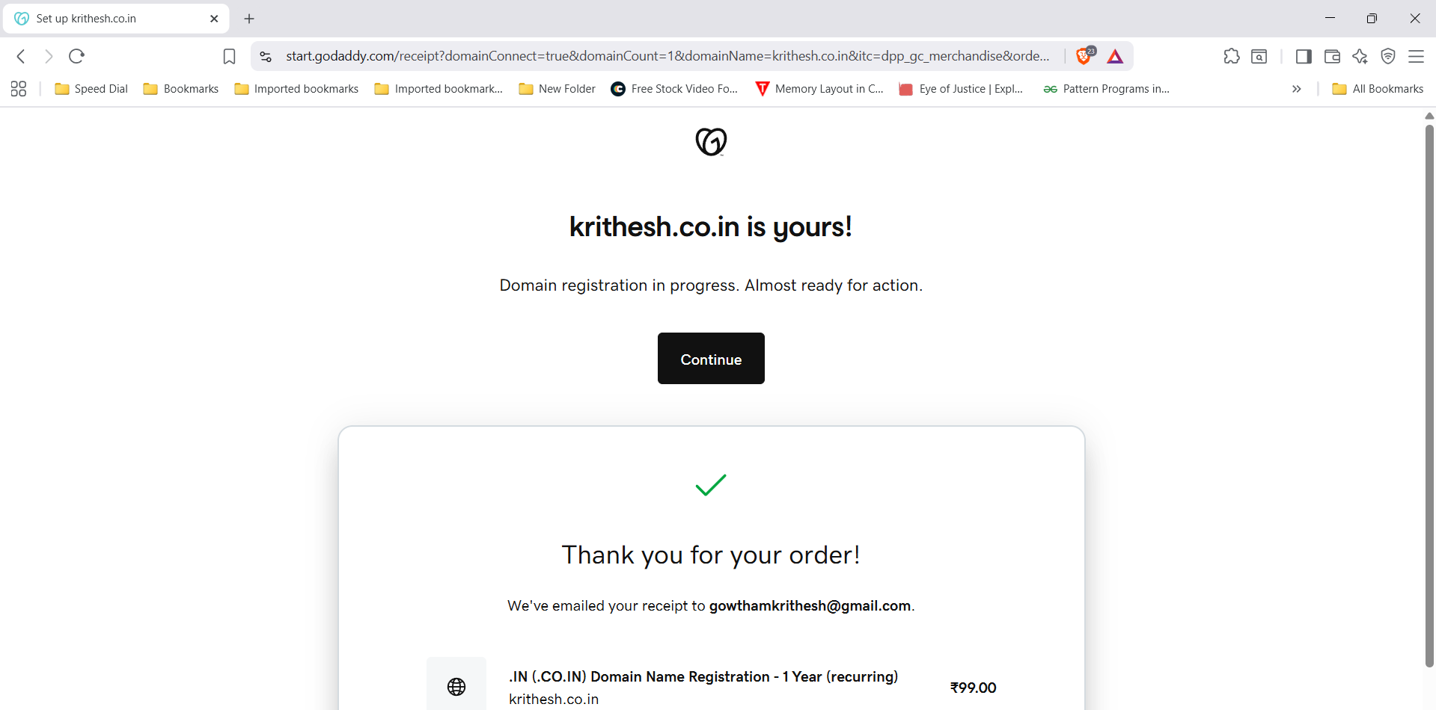

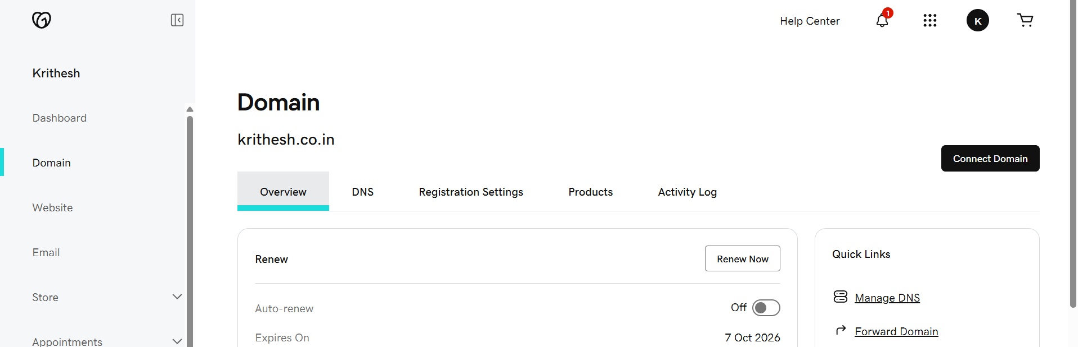

- Deploy static website in S3.
Step 1: Create a .html file and upload it to S3 bucket.
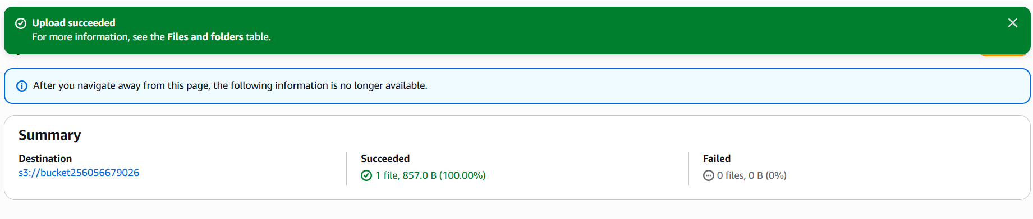

Step 2: Goto S3select a bucketpropertiesEdit static website hostingsave changes.
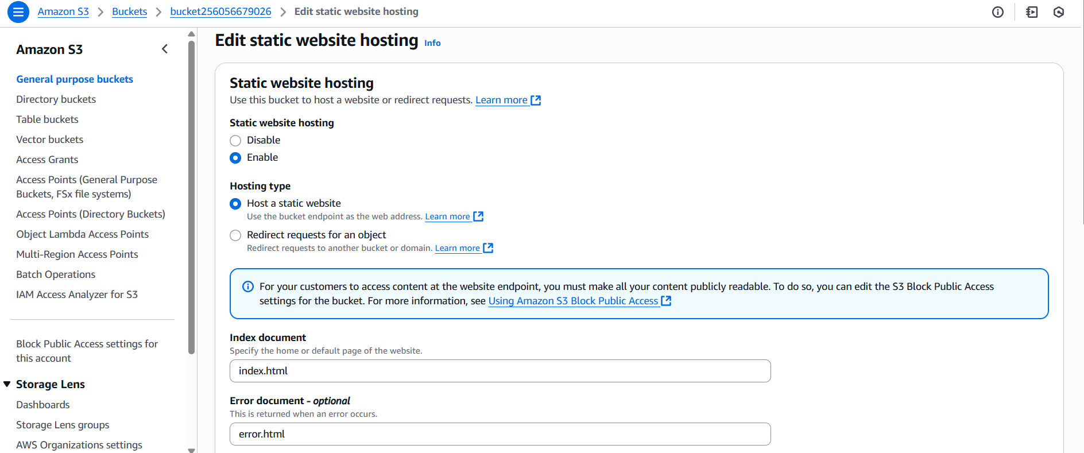
Step 3: Run the object URL in browser.
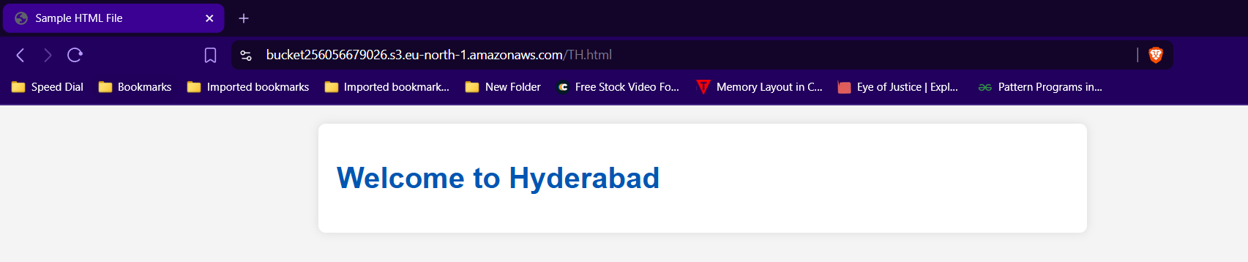

- Create a CDN and attach one SSL certificate.
Step 1: Create a S3 bucket with same domain name and enable static website hosting.
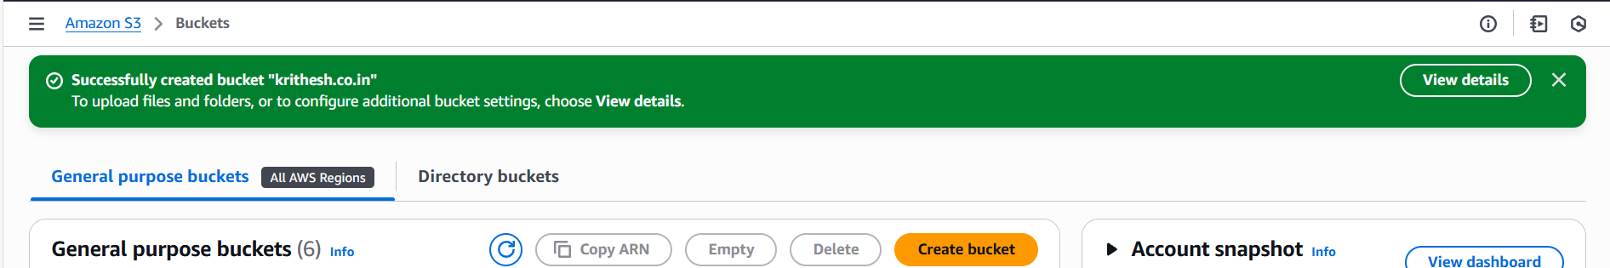
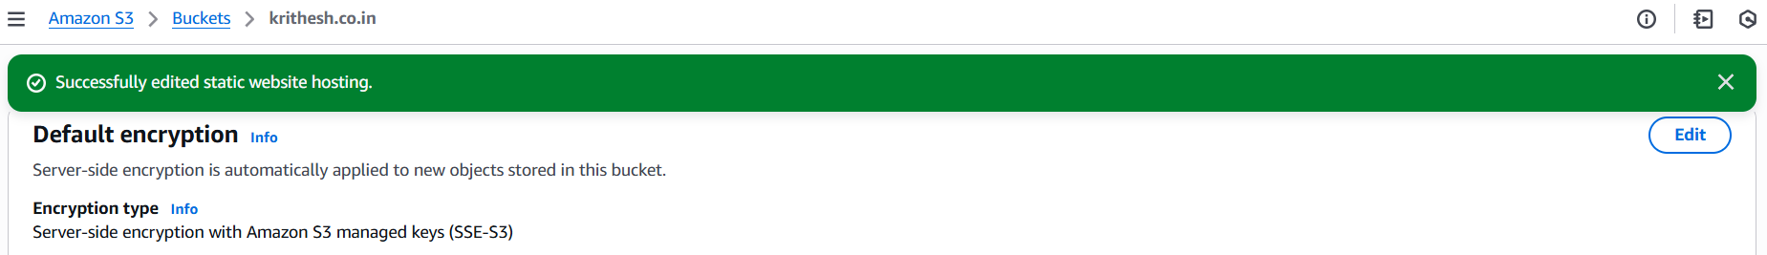

Step 2: AWS certificate managerRequest certificatepublic certificateenter detailsNext.
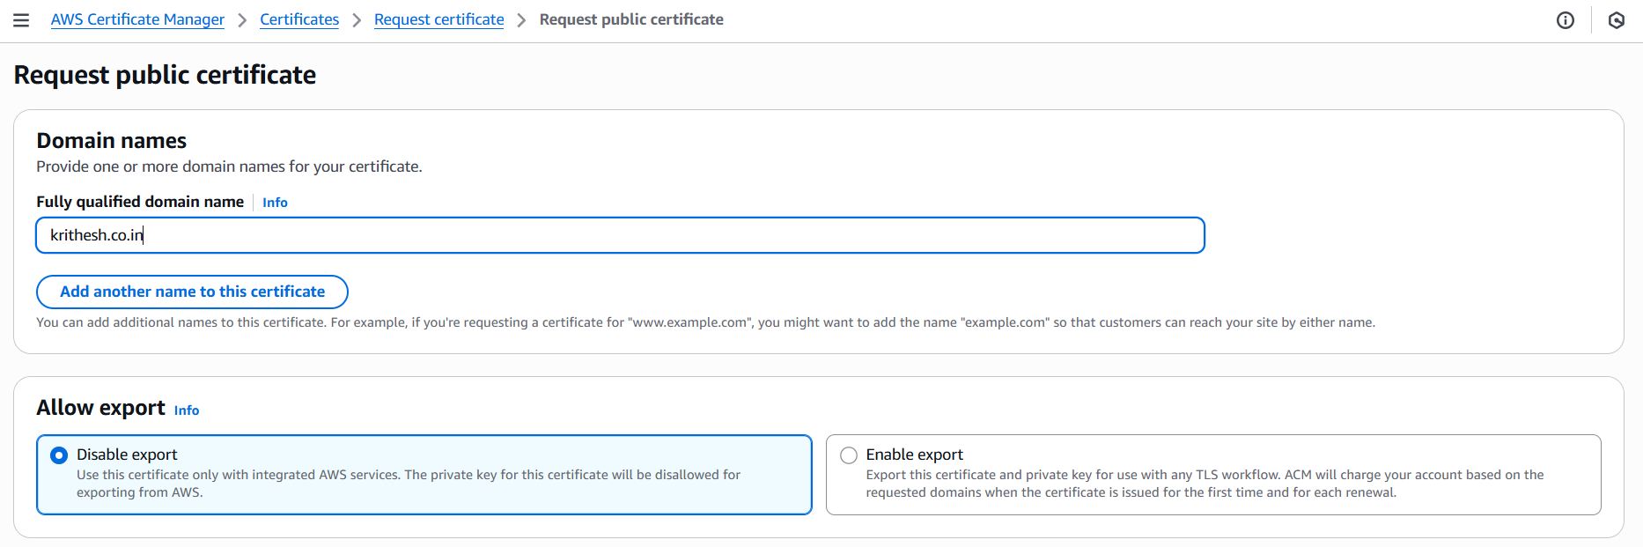

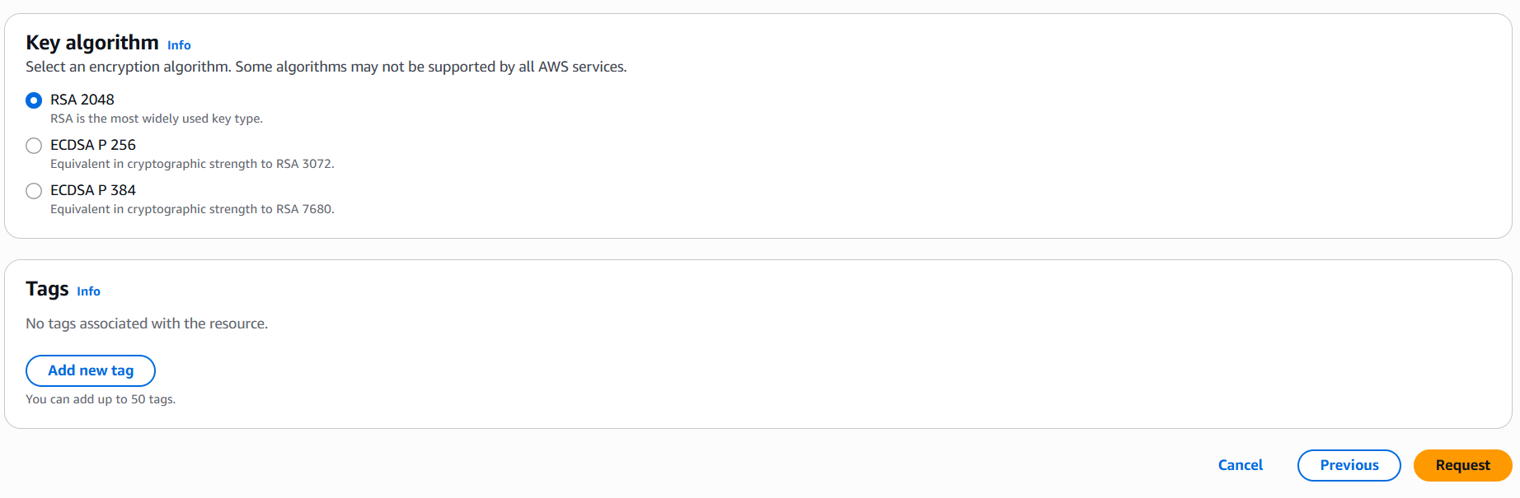
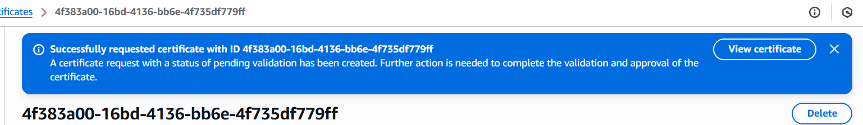
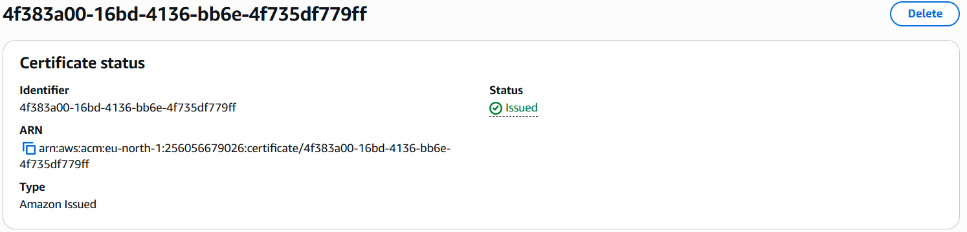
Step 3:Goto certificate and select create DNS records in AWS Route 53
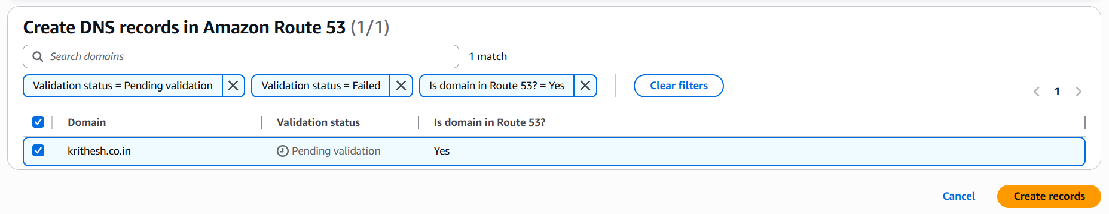
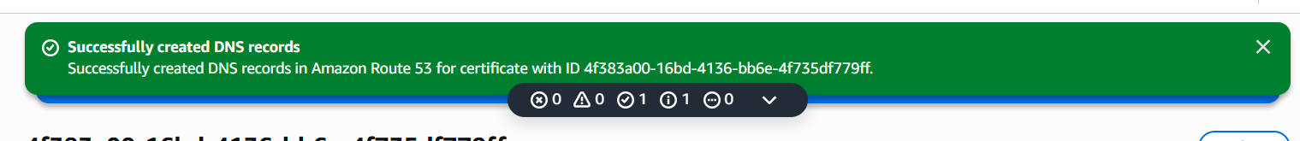
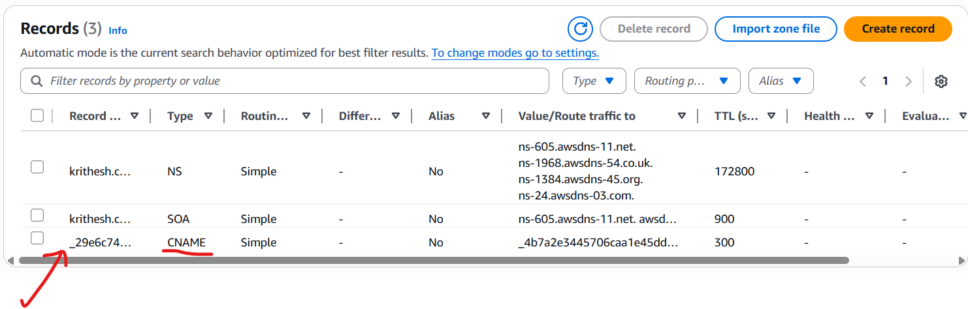

Step 4: Now Goto CloudFrontcreate distributionenter S3 bucket link and other details
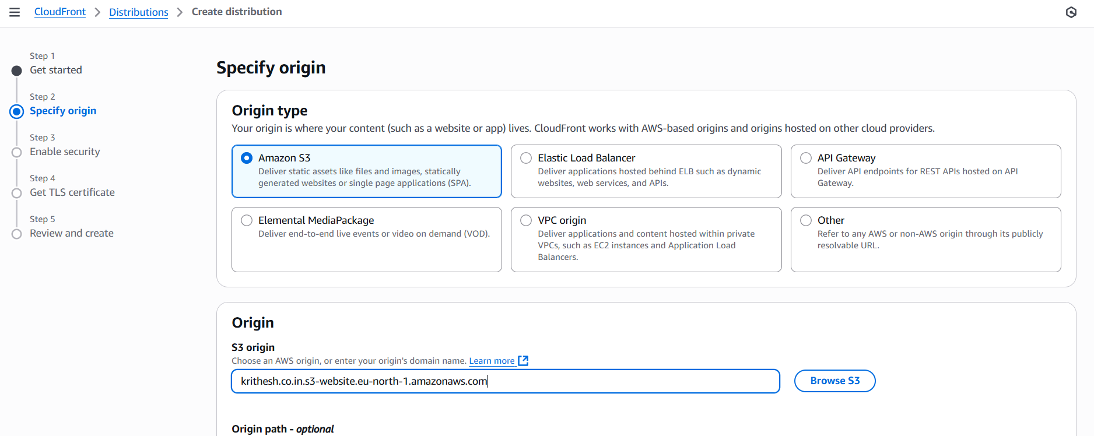
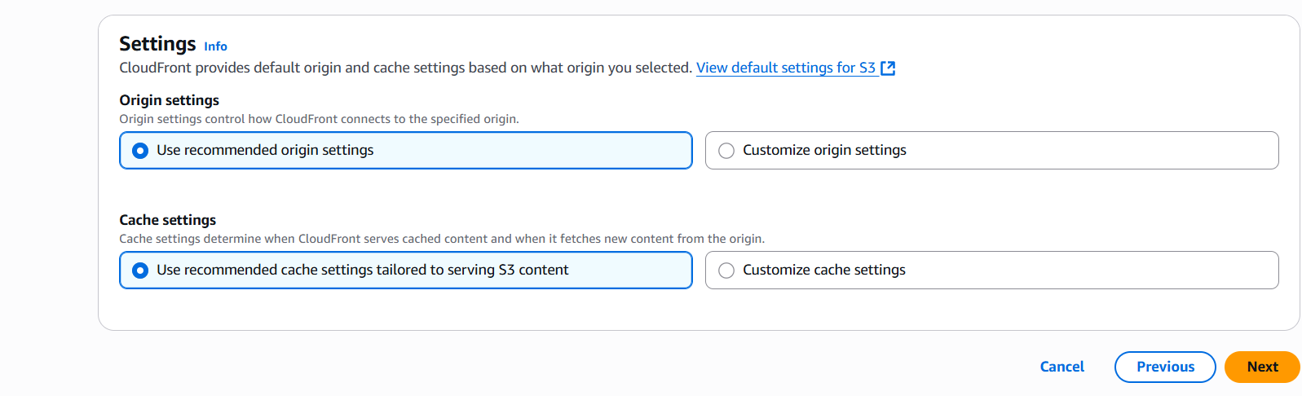
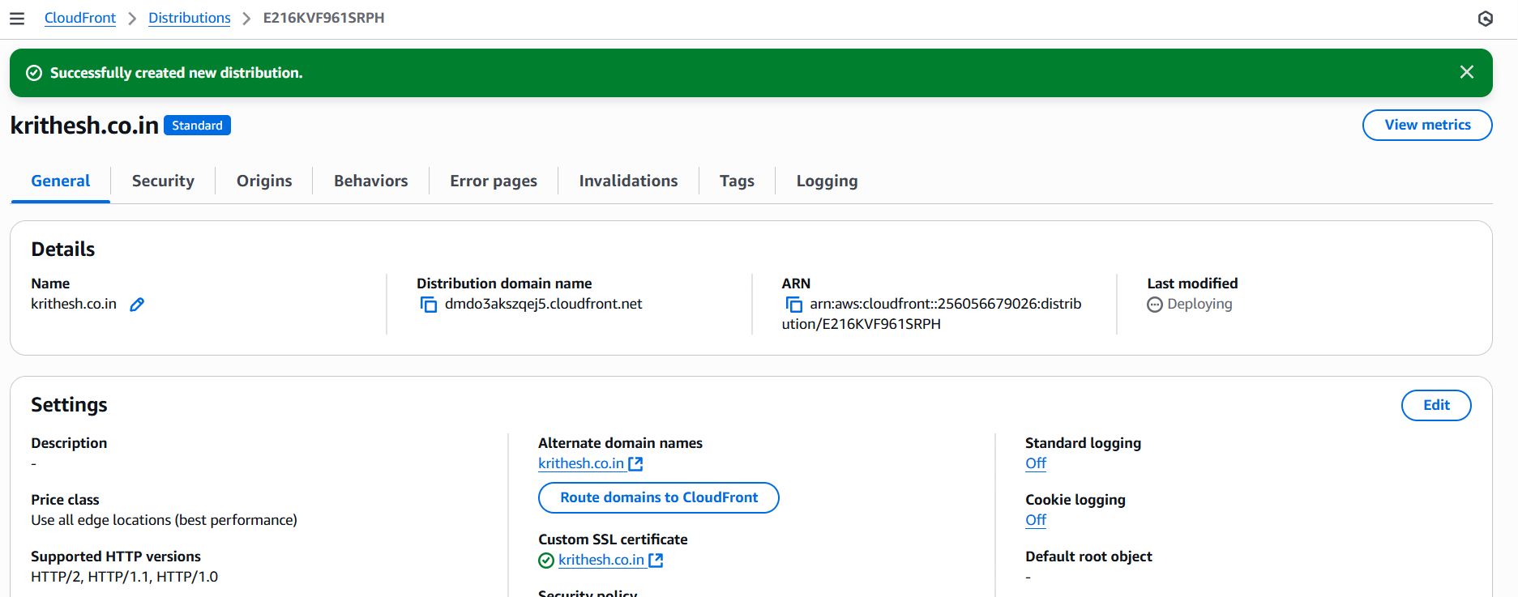

- Create a Route 53 hosted zone and map the domain with the CDN.
Step 1: Login to AWS & Goto R53Hosted Zonecreate Hosted zone
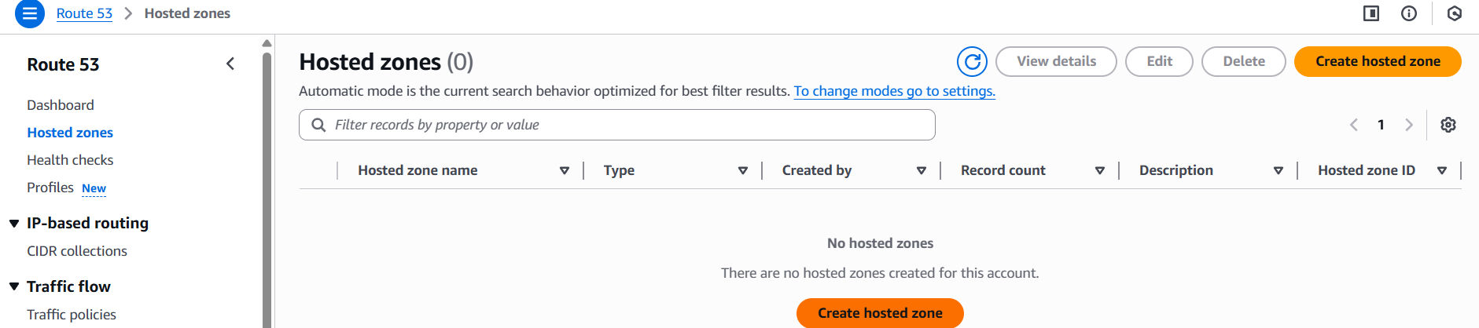
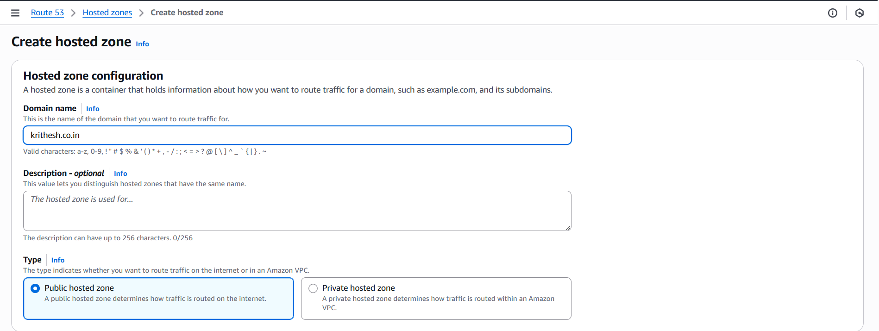
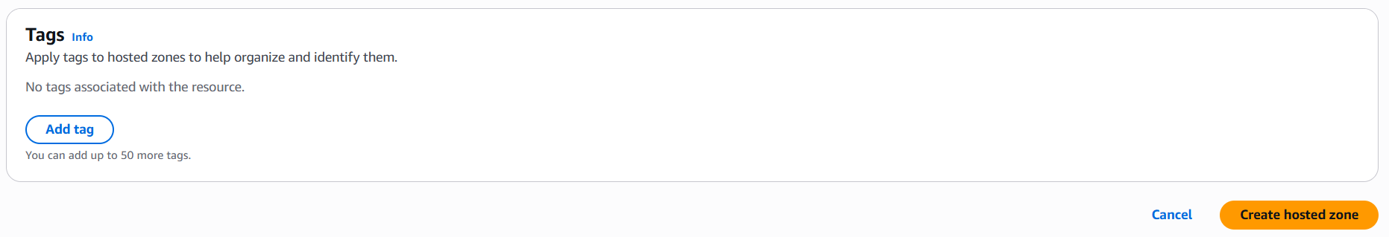
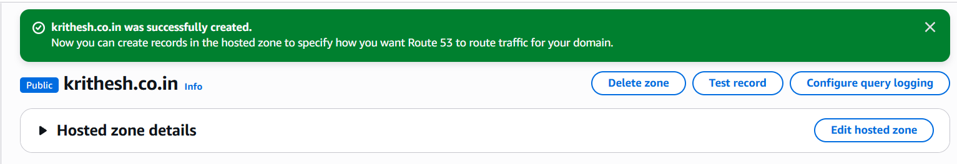
Step 2: Copy the records of Name server(NS) and configure it in the domain manager.
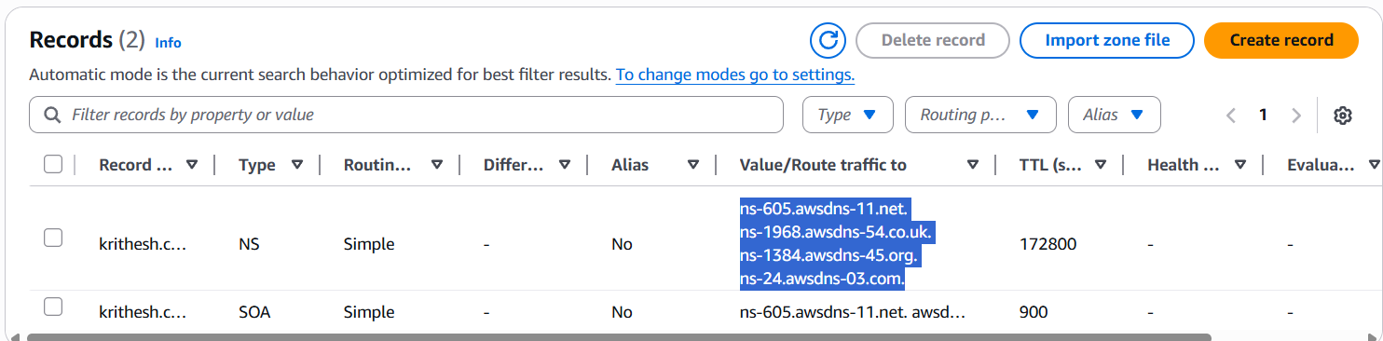

Step 3: Goto Domain managerselect Domainmanage domainDNSName serverchange NSI’ll use my own nameserversEnter and save it.
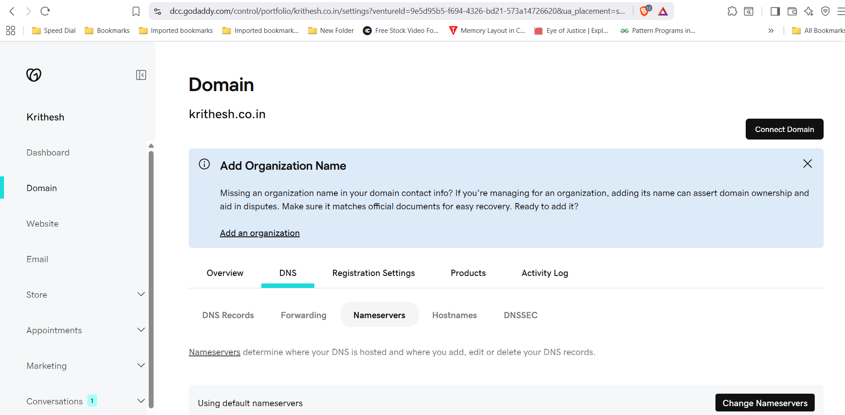
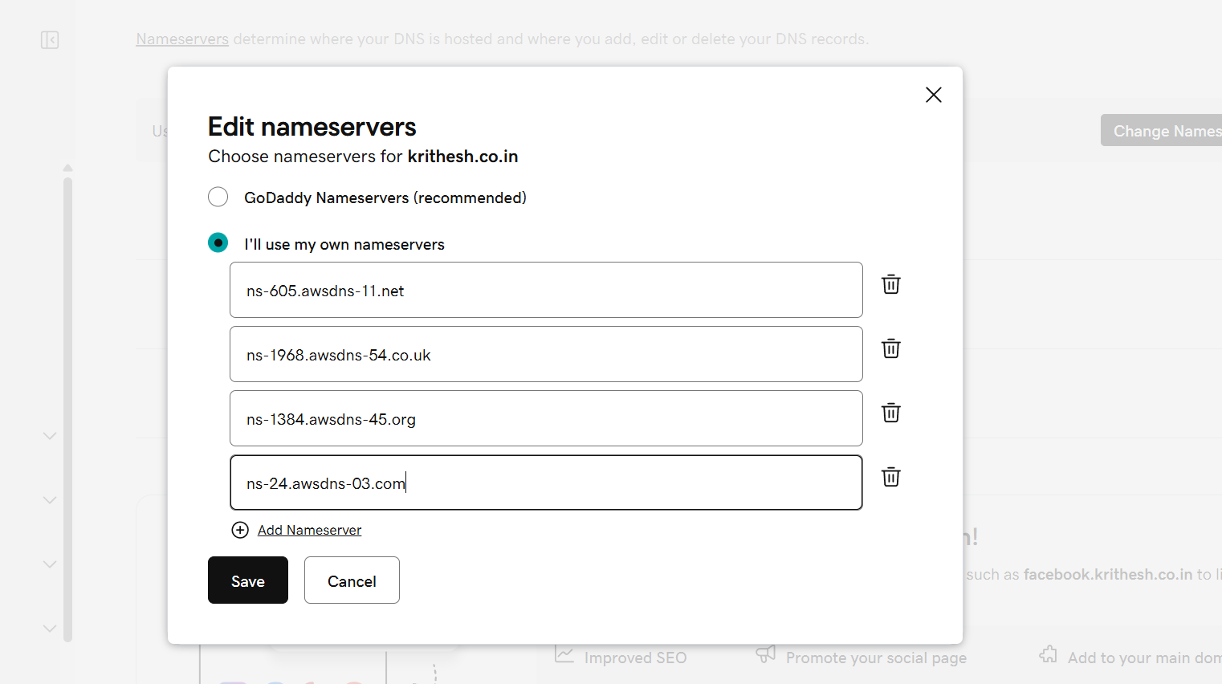
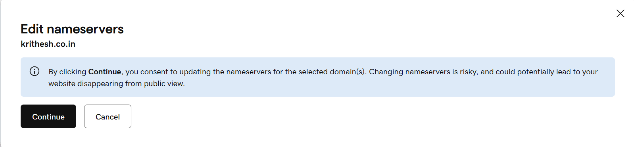

- Update the index.html in the S3 bucket and ensure the updated file is accessible using the domain name.
Step 1: Create a .html file and upload it to S3 bucket and make it public.
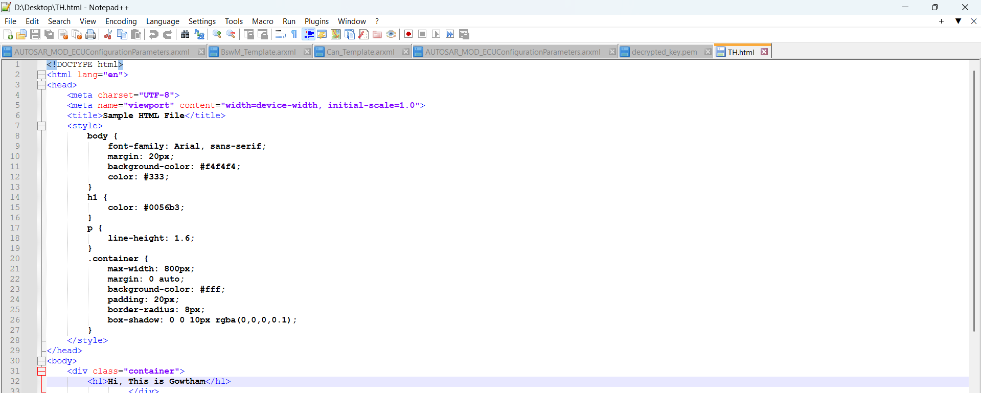
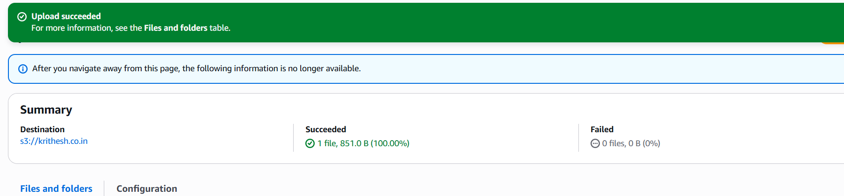
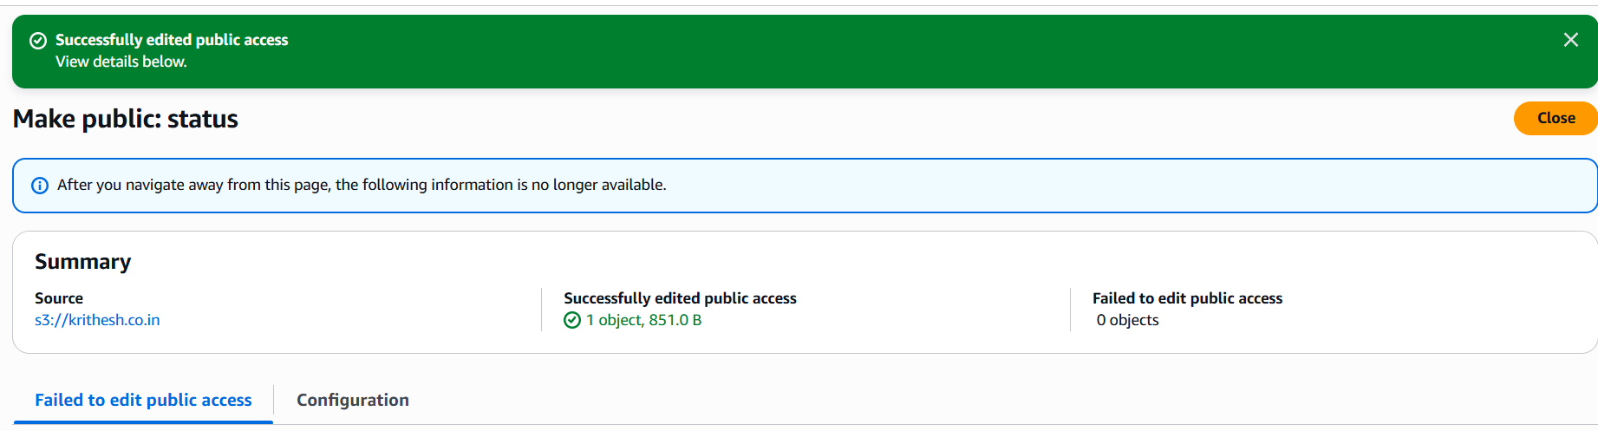
Step 2: Run your domain in browser.
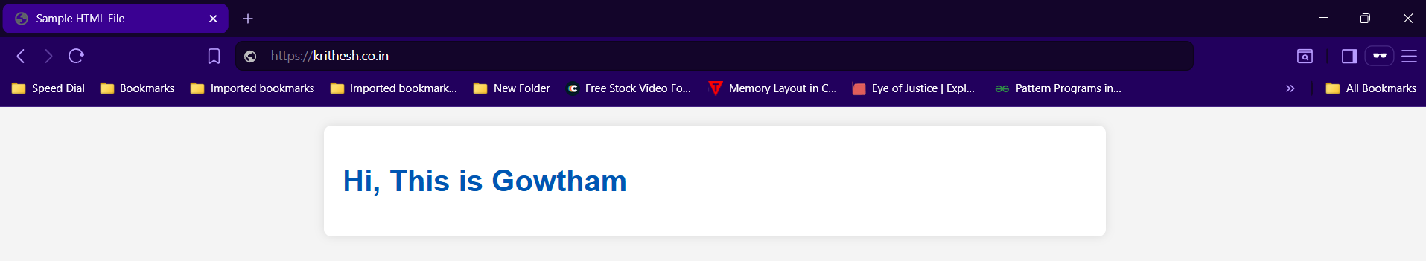

7. Share the domain name in Slack to test the connectivity.

https://krithesh.co.in

